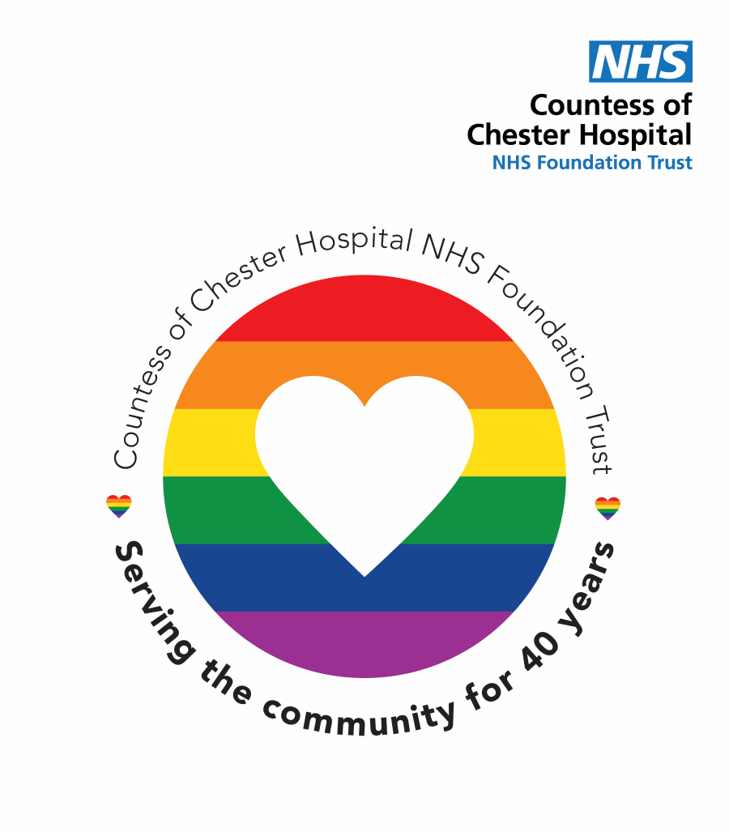

Equality, Diversity & Inclusion
Annual Monitoring
Report 2025-26

Equality, Diversity and Inclusion
Annual Monitoring Report
2025/2026

Foreword

We are pleased to present the Trust’s Equality, Diversity and Inclusion (EDI) Annual Monitoring Report for 2025/26, which sets out the progress made over the past year and provides an overview of our workforce equality profile.

At the Countess of Chester Hospital NHS Foundation Trust, equality, diversity and inclusion are central to our purpose and values. Our ambition is to be an organisation where everyone feels respected, valued and able to thrive, and where patients and communities experience care that is fair, inclusive and responsive to their needs.

This report highlights the actions taken during 2025/26 to embed EDI across the organisation, alongside areas where progress has been made and where further improvement is required. It also reflects our ongoing commitment to transparency and accountability through statutory workforce reporting and the Public Sector Equality Duty.

While we continue to see positive movement in a number of areas, we recognise that there is more to do to ensure equity of experience and opportunity for all. Our priorities for 2026/27 will build on this work, aligned to the Trust’s People Strategy, and will focus on strengthening inclusive leadership, addressing identified inequalities, and ensuring that the voices of our people continue to shape our approach.

I would like to thank our staff networks, trade union colleagues and teams across the Trust who have contributed to this work and supported progress during the year. Their commitment and challenge are essential as we continue to embed equality, diversity and inclusion in everything we do.



Vicki Wilson (She/Her)
Chief People Officer

Contents
1. Introduction 5
2. About the Trust 6
3. Equality, Diversity and Inclusion - Legislative and national requirements 7
4. Trust commitment to Anti-Racism 8
5. EDI Strategic Objectives 8
6. External Accreditations and/or Charter Marks 9
7. Key Achievements – 2025/26 9
8. Workforce Equality and Diversity Profile 11
9. EDI Priorities for 26/27 16
10. Governance and Accountability (how the Trust assures itself it is meeting national and statutory requirements) 16

Introduction

The purpose of this Annual Equality, Diversity and Inclusion (EDI) Report is to provide an overview of the Trust’s progress during 2025/26 in creating an inclusive place to work and receive care, where people are treated fairly, with dignity and respect. It outlines the Trust’s approach to EDI and summarises the key strategies, initiatives and actions taken to advance equality across the workforce. The report also presents analysis of workforce diversity across protected characteristics, including comparison with local population data, in line with the Trust’s Public Sector Equality Duty.

The key areas covered in this report include:
- The Trust’s approach to Equality, Diversity and Inclusion, including how EDI is embedded within organisational strategy, governance arrangements and the Trust’s People Strategy.
- Progress and key activity during 2025/26, highlighting initiatives, actions and areas of good practice that support an inclusive culture and fair experience for staff.
- Analysis of the workforce diversity profile, including representation across protected characteristics, pay bands and roles, with comparison to local population data in line with the Public Sector Equality Duty.
- Future priorities for 2026/27, setting out the Trust’s planned actions to address identified inequalities and support continued improvement in workforce equality and inclusion.
This report supports transparency and accountability in the Trust’s approach to equality, diversity and inclusion. While progress continues to be made in a number of areas, the Trust recognises that further work is required to address inequalities and to ensure a consistently inclusive experience for staff and patients. The actions and priorities set out within this report will continue to guide improvement and support the Trust’s ambition to be a truly inclusive organisation.

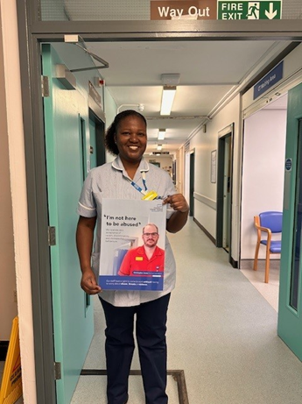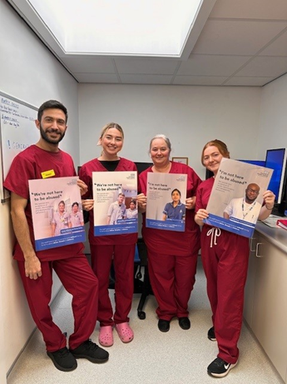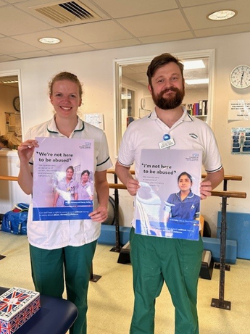

About the Trust

The Trust’s services are provided from three locations:

Countess of Chester Hospital providing 473 general and acute beds.

Ellesmere Port Hospital, providing 60 beds as a rehabilitation, intermediate and outpatient facility.
- Tarporley War Memorial Hospital, a base for community services which serve the local rural population.
The Countess of Chester Hospital NHS Foundation Trust employs approximately 5000 staff to provide care and treatment to a population of over 400,000 people living in Chester and West Cheshire which includes Ellesmere Port and Neston as well as the Deeside area of Flintshire.
The Trust works collaboratively within the wider Cheshire and Merseyside Integrated Care System. Due to its location on the border with North Wales, the Trust also works closely with the Betsi Cadwaladr University Health Board.
The Trust treats patients from England and some parts of Wales. During 2024/2025, there were approximately 643,000 patient attendances (inpatient, A&E, outpatient and diagnostic) ranging from a simple outpatient appointment to major cancer surgery.
Our vision: to achieve outstanding care for our patients and families
Our purpose: to improve the lives of our population by providing safe, kind and effective care.
Our Values:
- Safe: avoiding harm and reducing risk to all
- Kind: considerate and non-judgemental
- Effective: consistently maximising resources to deliver excellent and reliable care.

Equality, Diversity and Inclusion - Legislative and national requirements

As an NHS organisation, we have both a moral and legal duty to demonstrate fairness and equality to our patients, service users, workforce and local communities. As a public sector body our legal duties include the following.
- Equality Act 2010
Legally protects people from discrimination in the workplace and in wider society. It sets out the different ways in which its unlawful to treat someone and identifies that it is against the law to discriminate against anyone under the grounds of 9 protected characteristics
- Age  - Disability  - Race  - Sex  - Religion and/or Belief | - Sexual Orientation  - Gender Reassignment  - Pregnancy and Maternity  - Marriage and Civil Partnership

- Public Sector Equality Duty
As public sector organisations, all NHS providers are required to demonstrate how they meet the Public Sector Equality Duty as outlined in section 149 of the Equality Act 2010. The general duties of the Public Sector Equality Duty require organisation’s to:

Eliminate unlawful discrimination, harassment and victimisation and other conduct prohibited by the Equality Act 2010.

Advance equality of opportunity between people who share a protected characteristic and those who do not.

Foster good relations between people who share a protected characteristic and those who do not.

- The Health and Care Act 2022
This act added an additional legal duty on NHS organisations to consider health inequalities by addressing health inequity and social determinants of health directly. The legislative framework aims to support collaboration and partnership-working to integrate services for patients accessing care. Part of the measures included in the act are around changes to public health, social care, and the oversight of quality and safety.
In delivery of the above legal duties, the Trust is required to participate in and publish results annually in relation to the NHS Equality Delivery System, the Workforce Race Equality Standard, the Workforce Disability Equality Standard, and the Gender Pay Gap Report. All reports have been completed in line with statutory requirements and are available on the Trust website here.

Trust commitment to Anti-Racism

The Trust has made a clear anti-racism statement, acknowledging that racism exists within our communities, workplaces and, in particular, within the NHS. We recognise the impact that racism can have on staff experience, wellbeing and patient care, and we are committed to taking sustained action to address it.

Building on the Zero Tolerance campaign launched in 2024, further work was undertaken during 2025/26 to strengthen our approach. This has included the development and implementation of a Violence and Aggression Policy, enhanced staff support resources, and continued awareness-raising activity. Key initiatives during the year also included the celebration of Black History Month, supporting learning, dialogue and engagement across the organisation.

The Trust remains committed to eliminating racism in all its forms and to creating a safe, respectful and inclusive environment where all staff feel valued, supported and able to thrive.

EDI Strategic Objectives

Launched in 2023, our current Trust Strategy for Equality, Diversity and Inclusion vision is for the Countess of Chester NHS Foundation Trust to be and feel like a place where we all truly count.

Our strategic objectives commit to achieving the following outcomes:

- To grow a compassionate and inclusive culture, which is evidenced by our employee and patient voices.
- To evidence that we can meet the communication needs of patients and others, so that they are able to access all the services we offer.
- To widen participation in the delivery of Trust services for our local community by increasing employment opportunities across all protected characteristics.
- To evidence our people are better equipped and feel confident to spot and deal with EDI issues in their day-to-day work.
- To evidence social disadvantage and health inequalities are addressed by putting EDI at the heart of our institutional processes and decision making.
- To evidence out commitment for promotion of EDI best practice by being recognised as exemplar in the Northwest Region and beyond.

In November 2025, the Trust ratified a People Strategy 2025 – 2028 that reconfirmed their commitment to continue to develop workforce Equality, Diversity and Inclusion.

The Strategy outlines 4 key strands along with a broader commitment to creating the countess culture, with Equality, Diversity and Inclusion referenced within both Creating a sense of Belonging and creating the countess culture.

Our commitments within this strategy include that we will foster an inclusive and diverse workplace where every individual feels respected and valued, our people are treated fairly, and any inequalities are addressed. Key actions include strengthening our EDI strategies, ensuring representation at all levels and addressing disparities in recruitment, pay, progression and experience, and increasing awareness campaigns and culture events that highlight and celebrate the diversity of our workforce.

External Accreditations and/or Charter Marks

The Trust currently holds the following Equality, Diversity and Inclusion related accreditations and/or charter marks.



Key Achievements – 2025/26

- Launched and embedded a Trust approach to Flexible Working
This included a new policy and electronic process, ensuring all staff (including those with a disability or LTC) have access to flexible working to help them stay healthy in work. Over 500 staff have now utilised the new process to formerly request flexible working arrangements.

- Embedding and Extending the Trusts Health and Wellbeing offer for staff with Protected Characteristics
  - Launch of Stream, a financial wellbeing tool, further supporting staff to manage their finances.
  - Continued provision and promotion of the Trusts Employee Assistance Programme

- Targeting Workforce Health Inequalities
A calendar of health and wellbeing events have been delivered in 2025/26, targeting specific workforce health inequalities. These have included the following.
  - Recognizing the disproportionate impact of Diabetes on black and Asian communities, over 600 targeted emails were sent out to staff, with 115 diabetic assessments completed as part of a Diabetes Awareness Event targeting BAME colleagues.
  - Mental Health First Aid Training - Over the past year, our in-house trainer has equipped 43 colleagues with Mental Health First Aid skills. Mental health is embedded in the staff network activities, the Enabled Network held a Mental Health Day event

- Delivery of EDI Training and Awareness Sessions
  - Our overall Trust Equality, Diversity and Human Right Training compliance has remained consistently above target and as of February 26 is at 92%, demonstrating our staff commitment to learning about EDI.
  - Training compliance for LD and Autism Training e-learning has remained consistently above target and as of February 26 is currently at 93%
  - Sexual Safety e-learning has been launched across the Trust for all staff to complete.
  - Ongoing delivery of EDI Training and Awareness Sessions as part of management and leadership development
  - Bespoke sessions on EDI, bystander and unconscious bias training provided to teams and staff groups including to therapies, Ellesmere Port Hospital Staff, and Trust Apprentices.
  - The Trust supported 11 members of staff to complete the ethnically diverse leadership course (the Elevate Programme), with a commitment to support a further cohort in line with programme availability.
- Further development of our Trust Staff Networks 
  - 7 staff networks now established including the REACH network (formerly the BAME Network), the Women’s network, the LGBTQ+ network, the ENABLED network, the Parents and Carers network, the Faith and Belief Network and the Armed Forces and Veterans Staff Network.
  - Increased membership across all staff networks in year
  - Key Staff Network Achievements in year have included the following.
    - Enabled Network – In 2025 the network designed and launched an ENABLED Staff passport, supporting their members to have conversations with their managers regarding adjustments in the workplace to support them in staying healthy in work. The network keep there members up to date via a regular newsletter and have also hosted a Mental Health Awareness Day.
    - The Womens network has recruited new chairs and hosted there first Trust wide event celebrating International Womens Day
    - The Faith and Belief Network have been active in supporting all faiths throughout the year, including the Trusts Muslim staff through facilitating increased. In addition, the Faith and Belief network facilitated increased access for Muslim brothers and sisters to prayer facilities during Ramadan and providing Iftar bags to those staff who are shift for the break of fast.
    - The Armed Forces and Veterans Staff Network has been established with a chair recruited. The network encouraged staff from across both the Countess and Cheshire and Wirral Partnership to mark the Armistice. Working in partnership with the Faith and Belief Network, this was led by the Trusts Chaplain.

- Tackling Violence and Aggression against Staff
Launch of the Trust Violence and Aggression Policy and a refreshed approach to staff support process, including reference to staff with protected characteristics recognising that these staff can be more likely to experience violence, aggression or abuse in the workplace.

- Improved Governance for Workforce EDI
The Trust has developed an integrated EDI Action Plan for workforce that has been designed to ensure a coordinated and visible approach to improving EDI across the workforce. This is reported and monitored via the People and Culture Sub-Committee with bi-annual reporting to People Committee in October and April.

Workforce Equality and Diversity Profile

Diversity Profile and Report Data – Principles

The data used in this report is sourced from Electronic Staff Record (ESR), the Office of National Statistics and the 2021 Census. Within ESR certain protected characteristics may have data quality gaps, where colleagues have been given the option not to disclose. This is a common dynamic across most NHS Organisations. The numbers of colleagues who have experienced formal procedures during their employment, is relatively low, meaning that any comparative analysis will not have high statistical value.

Workforce Breakdowns

This data below provides insights into how the workforce has changed over the previous twelve months.

Total Staff in Post (Substantive and Bank, including by Pay Grade)
Overall, staff numbers by headcount and pay grade by percentage have remained fairly stable in year. The overall staffing headcount as of 31st December 2025 was 5,853, which is a decrease of 39, (0.7%) from the previous year. The highest numbers of colleagues employed continue to be in Bands 1 & 2 and Band 4 pay bands.
Pay Grade by Percentages
Pay Grade | Headcount  2024 | Headcount  2025
Apprentice | 0.27% | 0.24%
Band 1 & 2 | 20.38% | 24.06%
Band 3 | 5.33% | 5.57%
Band 4 | 19.02% | 19.19%
Band 5 | 11.35% | 11.48%
Band 6 | 7.70% | 7.77%
Band 7 | 2.88% | 3.01%
Band 8a | 0.73% | 0.72%
Band 8b | 0.32% | 0.43%
Band 8c | 0.20% | 0.19%
Band 8d | 0.14% | 0.14%
Band 9 | 0.32% | 0.29%
Senior Manager | 5.38% | 6.68%
M&D - Career Grade | 1.02% | 1.01%
M&D - Consultant | 5.06% | 5.16%
M&D - Doctors in Training | 19.90% | 14.08%

Pay Grade by Headcount
Pay Grade | Headcount  2024 | Headcount  2025
Apprentice | 16 | 14
Band 1 & 2 | 1201 | 1408
Band 3 | 314 | 326
Band 4 | 1121 | 1123
Band 5 | 669 | 672
Band 6 | 454 | 455
Band 7 | 170 | 176
Band 8a | 43 | 42
Band 8b | 19 | 25
Band 8c | 12 | 11
Band 8d | 8 | 8
Band 9 | 19 | 17
Senior Manager | 317 | 391
M&D - Career Grade | 60 | 59
M&D - Consultant | 298 | 302
M&D - Doctors in Training | 1173 | 824
Trust Total | 5894 | 5853

Total Staff in Post – Ethnicity Breakdown

Ethnicity by Headcount
Ethnicity | Headcount  2024 | Headcount  2025
BAME | 1060 | 1196
White | 4738 | 4539
Not Stated | 96 | 118
Ethnicity by Percentages
Ethnicity | Headcount  2024 | Headcount  2025
BAME | 17.98% | 20.43%
White | 80.39% | 77.55%
Not Stated | 1.63% | 2.02%

Ethnicity declaration rates for the Trust Workforce was around 98% in 2025/2026. This provides increased assurance of accuracy throughout the workforce analysis; gaps in the known status in any of the protected characteristics can hinder statistical analysis.

When compared to the previous year, the percentage of colleagues from a BAME background in our workforce increased by 2.45% from 17.98% to 20.43%. This continues the previous years trend of increasing ethnic diversity within the organisation.

The Trusts workforce BAME representation at 20.43% is significantly higher than the local community percentage population of 4.6 % as per the 2021 Census.
BAME Groupings (Including White - Other) | Headcount  2024 | Headcount  2025
Asian | 40.93% | 41.91%
Black | 21.88% | 23.16%
Mixed | 6.35% | 6.27%
Other | 5.65% | 6.02%
White - Other | 25.19% | 22.64%

The Asian BAME grouping remains the largest within the Black and minority ethnic profile, accounting for around 41.91% of all BAME staff, followed by Black grouping at 23.16%.

Total Staff in Post – Sex Breakdown

Gender by Headcount
Gender by Percentages

Gender | Headcount  2024 | Headcount  2025
Female | 4583 | 4494
Male | 1311 | 1359
Gender | Headcount  2024 | Headcount  2025
Female | 77.76% | 76.78%
Male | 22.24% | 23.22%

Whilst there has been a slight increase in the number of men employed by the organisation, women continue to make up a significant proportion of the workplace at 76.78%. This is in comparison to the local population where women make up 51.19% of the total population. This trend is not unusual for NHS Provider Trusts, however there is significant variation in the spread of male and female employees across the bands as highlighted within the Trusts Gender Pay Gap Report.

Total Staff in Post – Disability Breakdown

Disability by Headcount |  |  |  |  | Disability by Percentages
Disability | Headcount  2024 | Headcount  2025 |  |  | Disability | Headcount  2024 | Headcount  2025
No | 5024 | 5000 |  |  | No | 85.24% | 85.43%
Not Declared | 522 | 508 |  |  | Not Declared | 8.86% | 8.68%
Yes | 348 | 345 |  |  | Yes | 5.90% | 5.89%
Trust Total | 5894 | 5853

The number of colleagues who indicated they have a disability has remained static in year, with 345 staff declaring a disability equating to 5.89% of the total workforce. 8.68% of staff have not declared a disability, indicating that there may be further work to do to understand why disclosure rates within ESR or lower than some of the other protected characteristics.
In comparison, local population data identifies 17.9% disabled people living in Cheshire West and Chester, meaning that the workforce is potentially underrepresenting the community in its workforce profile relating to disability.

Total Staff in Post – Age Breakdown

Age Band by Headcount |  |  |  |  | Age Band by Percentages
Age Band | Headcount  2024 | Headcount  2025 |  |  | Age Band | Headcount  2024 | Headcount  2025
20 & Under | 87 | 67 |  |  | 20 & Under | 1.48% | 1.14%
21-30 | 1221 | 1190 |  |  | 21-30 | 20.72% | 20.33%
31-40 | 1654 | 1730 |  |  | 31-40 | 28.06% | 29.56%
41-50 | 1248 | 1225 |  |  | 41-50 | 21.17% | 20.93%
51-60 | 1147 | 1115 |  |  | 51-60 | 19.46% | 19.05%
61-70 | 500 | 487 |  |  | 61-70 | 8.48% | 8.32%
71 & Over | 37 | 39 |  |  | 71 & Over | 0.63% | 0.67%
Trust Total | 5894 | 5853

The age profile of the Trust’s workforce has remained fairly stable between 2024 and 2025 with slight decreases across all age bands apart from 31-40 and 71 and over age bands.
Local population data identifies the largest age group percentages in the ranges 50 – 64 years and 35 – 24 years that is broadly comparable to the Trusts workforce profile. 4.1% of the local population is aged 16-19 years, indicating that the Trust workforce of 20 & under may be under-representative of the local community.

Total Staff in Post - Religion & Belief Breakdown

Religious Belief by Headcount |  |  |  |  | Religious Belief by Percentages
Religious Belief | Headcount  2024 | Headcount  2025 |  |  | Religious Belief | Headcount  2024 | Headcount  2025
Atheism | 1021 | 1014 |  |  | Atheism | 17.32% | 17.32%
Buddhism | 33 | 35 |  |  | Buddhism | 0.56% | 0.60%
Christianity | 3092 | 3039 |  |  | Christianity | 52.46% | 51.92%
Hinduism | 129 | 140 |  |  | Hinduism | 2.19% | 2.39%
Islam | 153 | 171 |  |  | Islam | 2.60% | 2.92%
Jainism | 1 | 2 |  |  | Jainism | 0.02% | 0.03%
Judaism | 7 | 4 |  |  | Judaism | 0.12% | 0.07%
Not Recorded | 965 | 977 |  |  | Not Recorded | 16.37% | 16.69%
Other | 486 | 463 |  |  | Other | 8.25% | 7.91%
Sikhism | 7 | 8 |  |  | Sikhism | 0.12% | 0.14%
Trust Total | 5894 | 5853

Christianity remains the predominant religion or belief at 51.92% a slight decrease from 52.46% in 2024.Those who have not recorded has increased slightly from 16.37% to 16.69%, indicating that there is further opportunity to encourage disclosures relating to this protected characteristic. The 2021 census reports Christianity as the highest percentage religion, with a 54% stating it as their religious belief. 38% of the local population have declared no religion, with 1.0 % reporting a Muslim faith and 0.4% reporting a Hindu faith. Whilst the Trusts workforce is representative of the community in relation to Christian faith, the Trust reports higher diversity in relation to Islamic faith and Hinduism.

Total Staff in Post – Sexual Orientation

Sexual Orientation by Headcount |  |  |  |  | Sexual Orientation by Percentages
Sexual Orientation | Headcount  2024 | Headcount  2025 |  |  | Sexual Orientation | Headcount  2024 | Headcount  2025
Bisexual | 72 | 71 |  |  | Bisexual | 1.22% | 1.21%
Gay or Lesbian | 109 | 105 |  |  | Gay or Lesbian | 1.85% | 1.79%
Heterosexual or Straight | 5110 | 5062 |  |  | Heterosexual or Straight | 86.70% | 86.49%
Not Recorded | 579 | 589 |  |  | Not Recorded | 9.82% | 10.06%
Other sexual orientation not listed | 11 | 14 |  |  | Other sexual orientation not listed | 0.19% | 0.24%
Undecided | 13 | 12 |  |  | Undecided | 0.22% | 0.21%
Trust Total | 5894 | 5853

The highest sexual orientation is ‘Heterosexual’ which has decreased slightly from 2024, 86.70% to 86.49% There was a small increase noted in the percentage of colleagues who did not wish to disclose from 9.82% in 2024 to 10.06% in 2025. According to the 2021 census, 91.2% of people identify as Heterosexual in the local population, with 1.4% identifying as Gay or Lesbian and 1.1% identifying as bisexual, suggesting that there is slightly higher diversity within our workforce when compared to our local population.

Diversity Profile – Summary

Overall, the Trust’s workforce profile has remained broadly stable during 2025/26, with some areas of positive movement and others where continued focus is required. Ethnic diversity within the workforce has continued to increase, with Black and minority ethnic representation now significantly higher than that of the local population, reflecting the Trust’s ongoing success in attracting and retaining a diverse workforce.
The Trust remains a predominantly female workforce, consistent with the wider NHS, with variation in gender representation across pay bands reflected within the Gender Pay Gap analysis. The age profile of the workforce broadly mirrors the local working-age population, although there is some under-representation of younger staff aged 20 and under, indicating an opportunity to further strengthen early-career pathways.
Representation of staff declaring a disability has remained static and continues to be lower than local population levels, highlighting an ongoing challenge around both attraction and disclosure. While disclosure rates for most protected characteristics are relatively high, levels of non-declaration remain more pronounced in some areas, which can limit the depth of analysis and understanding of staff experience.
In relation to religion and sexual orientation, the Trust’s workforce demonstrates higher levels of diversity than the local population, with representation broadly reflective of national NHS trends. The Trust recognises the importance of continuing to promote safe and inclusive environments that encourage disclosure and ensure all staff feel supported.
Taken together, the workforce profile demonstrates areas of strength alongside clear priorities for improvement. These findings continue to inform the Trust’s EDI priorities and targeted actions for 2026/27, ensuring focus is directed to where it will have the greatest impact.

EDI Priorities for 26/27

Our priorities for 2026/2027 will build on the work undertaken in 2025/26, taking into account our People Strategy and the analysis and action planning that has been ongoing during this period. We will:
- Refresh the strategic direction for Workforce EDI that builds on the commitments made within the Trusts People Strategy. This includes
  - Strengthening our EDI Strategies, ensuring representation at all levels and addressing disparities in recruitment, pay, progression and experience
  - Increase awareness campaigns and cultural events that highlight and celebrate the diversity of our workforce
  - Expand and empower staff networks, ensuring diverse voices are heard and influence decision making.
- Take specific actions relating to the feedback from our staff and Trust self-assessment against statutory reporting requirements that will include the following.
  - Further develop and embed Equality Impact Analysis within Trust decision making
  - Further develop and embed a Zero Acceptance campaign in relation to staff experience of Violence, Aggression, Abuse, Racism and Unwanted Sexual Behaviour.

Governance and Accountability

The Trust assures itself that it is meeting its national and statutory Equality, Diversity and Inclusion obligations through established governance arrangements that reflect its duties under the Public Sector Equality Duty (PSED) as both an employer and a provider of services.

As an employer, workforce Equality, Diversity and Inclusion is overseen through the Trust’s Board-level People Committee, where EDI is embedded within the Committee’s cycle of business. Oversight is supported through the People & Culture Sub-Committee, ensuring that EDI is consistently mainstreamed within people governance. Clear executive accountability is in place for the delivery and assurance of workforce EDI priorities.

Accountable Officer for Workforce EDI: Vicki Wilson – Chief People Officer

As a service provider, responsibility for patient Equality, Diversity and Inclusion is overseen through the Trust’s Quality Committee, ensuring alignment with quality, safety and patient experience governance. The Trust recognises that focus on patient EDI has been more limited to date and therefore strengthening our approach to patient equality, health inequalities and inclusive service delivery will be a priority area of focus during 2026/27.

Accountable Officer for Patient EDI: Sue Pemberton, Director of Nursing & Deputy Chief Executive

This report has been prepared with thanks to our EDI networks, Workforce Information colleagues, Recruitment colleagues and everyone at Countess of Chester Hospital NHS Foundation Trust.

