PATHOLOGY - Information for Patients

Information for patients

Where do I go for my blood tests?
Your GP may provide Phlebotomy (blood sample) services in your own surgery. If not, drop-in sessions are available at the Countess of Chester Hospital and Ellesmere Port Hospital (see outpatient services below).

Inpatients:

All COCH wards | 07.30-12.30, 13:00-17:00 Monday to Friday  07.30-12.30 on Weekends  *Please note that Ward 33 and Theatre Admissions Lounge (TAL) are not covered at Weekends*
EPH wards | 07.30-08.30 Monday to Friday
CWP NHS Trust Wards (Bowmere Hospital) | 10.30-12.00 Mon-Wed-Fri  *Please note that this is not currently covered by the COCH Phlebotomy service*

Outpatient Departments(OPD)/GP:

OPD3 at COCH – Clinic Blood Tests | 08.30-17.00 Monday to Friday (Last patient 16.50)
1829 Building, COCH - GP Blood Tests  (By appointment only) | 08.30 – 16.00 Monday to Thursday (Last appointment 15.50) and closed on a Friday
EPH – Clinic Blood Tests | 13.30 – 17.00 Monday (last patient 16.50)  08.30 - 12.30 & 13.00 - 17.00 (last patient 16.50) Tuesday  08.30 - 12.30 Friday
Great Sutton Medical Centre, Ellesmere Port, CH66 3NZ - GP patients in the Ellesmere Port area (By appointment only) | 07.30 – 16.00 Monday to Friday
To book an appointment for a patient under the age of 12 please contact Paediatric Outpatients on 01244 365082

GP Patients:
The Phlebotomy Service for GP Patients is located in the 1829 Building at the Countess of Chester Hospital (situated to the right as you come off the roundabout at the entrance to the Health Park) and Great Sutton Medical Centre, Ellesmere Port. There is a free Car Park just in front of the Phlebotomy entrance at both sites.
Blood Tests for GP patients will be BY APPOINTMENT ONLY.
To book a blood test appointments please go to the Hospital website: www.coch.nhs.uk/blood-test-booking
Choose a location, time and date convenient for you to have your bloods taken.
Appointments are available from: Monday – Thursday, 8.30am-15.50pm (Excluding Bank Holidays) at 1829 Building, COCH and Monday-Friday, 07:30am-16:00pm at Great Sutton Medical Centre, Ellesmere Port. If you do not have access to the internet, then please call your GP practice who will be able to book an appointment for you.
Fasting Patients – please refer to Fasting Blood Tests Guidelines when booking.
Glucose Tolerance Tests:
GTTs are performed by individual GP surgeries and reports are sent electronically. A protocol is available on SharePoint for the use of GTTs in the hospital for inpatients.

Information about having a blood sample taken
A blood test is taking a sample of blood for testing in a laboratory. Blood tests have a wide range of uses and are one of the most common types of medical tests.

A blood test can be used to:
- assess your general state of health
- confirm the presence of a bacterial or viral infection
- see how well certain organs, such as the liver and kidneys are functioning
- screen for certain genetic conditions such as cystic fibrosis or spinal muscular atrophy

Most blood tests only take a few minutes to complete and are carried out at your GP surgery or local hospital.

Preparing for a blood test
The healthcare professional who arranges your blood test will tell you whether there are any specific instructions you need to follow before your test.

Depending on the type of blood test, you may be asked to:
- avoid eating or drinking anything apart from water (fasting)
- stop taking a certain medication

What happens during a blood test?

A blood test usually involves taking a blood sample from a blood vessel in your arm.
The arm is a convenient part of the body to use because it can be easily uncovered. The usual place for a sample to be taken from is the inside of the elbow or wrist, where the veins are relatively close to the surface.

Blood samples from children are usually taken from the back of the hand. For children attending the Pediatric Dept. for a blood test, the child's hand will be anaesthetised (numbed) with a special cream before the sample is taken. For children over 12 attending OPD3, 1829 Building or Great Sutton Medical Centre, they will not be anaesthetised.

A tight band (tourniquet) is usually put around your upper arm. This squeezes the arm, temporarily slowing down the flow of blood out of the arm and causing the vein to swell with blood. This makes it easier for a blood sample to be taken.

Before taking the sample, the healthcare professional will ask you to confirm your identity and as long as you understand the examination about to take place then you will present your arm for venipuncture. This is considered a form of consent to the procedure. The healthcare professional may need to clean the area with an antiseptic wipe before taking the sample. A needle attached to a syringe or to a special blood-collecting container is pushed into the vein. The syringe is used to draw out a sample of your blood. You may feel a slight pricking sensation as the needle goes in, but it should not be painful. If you do not like needles and injections, tell the person who is taking the sample so they can make you more comfortable. If you feel faint, lie down.
When the sample has been taken, the needle will be removed. Pressure is applied to the tiny break in the skin for a few minutes using a cotton-wool pad to stop the bleeding and to prevent bruising. A plaster may then be put on the small wound to keep it clean and prevent infection.

After the test

Only a small amount of blood is taken during the test so you shouldn't feel any significant after-effects. However, some people do feel dizzy and faint during and after the test. If this happens to you, tell the person carrying out the test so they can help you feel more comfortable.
After a blood test, you may have a small, bruised area on your skin where the needle went in. Occasionally, a larger area of bruising may appear. This can be because there was a lack of pressure at the site of the needle or the blood vessel was damaged by the needle.
Bruises can be painful but are usually harmless. However, tell your GP if you frequently get bruises after having a blood test.

Results

After the blood sample has been taken, it will be put into a bottle and labelled with your name. It will then be sent to a laboratory for testing. The results are sent back to the hospital or to your GP, and you will be told when and how you will be given your results.

Sometimes, receiving results can be stressful and upsetting. If you are worried about the outcome of a test, you may choose to take a trusted friend or relative with you. For some tests, such as HIV, you will be offered specialist counselling to help you deal with your results.

Information about laboratory tests can be found at the following website: http://labtestsonline.org.uk/

Please be aware that although most routine testing is carried out in the laboratory at the Countess of Chester Hospital, more specialist tests may be required to be sent to other local or regional hospitals for processing. Please contact the laboratory if any more information is required on referred testing.

Delivering a sample to Pathology
The Countess Pathology Department is located at the rear of the main hospital on the first floor in the Orange zone. Follow the signs for Pathology F12 and go to Pathology Reception which is just inside the main entrance door to the pathology area opposite CCU. The reception is open from 8:00 am to 22.00pm Monday to Friday and 09:00 to 17:30pm on the weekends. Samples can also be collected from GP surgeries by our dedicated courier service.

Samples for Microbiology can be received here at COCH for onward transport to the Cheshire and Wirral Microbiology Services site at Bromborough. Blood Cultures must be delivered to the Specimen Reception as soon as possible, prior to delivery to Microbiology.

NB: Semen samples must be delivered to the Fertility Unit in the Women and Children’s Building, COCH.

24-hour urine collection
What is a 24-hour urine sample?
A 24-hour urine sample is a collection of all the urine you pass over a period of 24 hours.

What are the benefits of a 24-hour urine sample?
The benefit of a 24-hour urine sample is that it can help your doctor to diagnose your condition or monitor treatment you are having. Because the urine we produce varies throughout the day and night, the differences are ‘averaged out’ by collecting all urine over 24 hours, so we can get a more reliable result than a single urine sample for some tests.

What are the risks of a 24-hour urine sample?
There are no risks to collecting a 24-hour urine sample but in a few cases the test may need to be repeated. This could be due to technical reasons, because the results are not clear, or the instructions have not been followed carefully.

Are there any alternative tests?
There are no alternative tests that will give your doctor the information they need to monitor your treatment or make a diagnosis.

What are the risks of declining a 24-hour urine sample?
If you do not wish to collect a 24-hour urine sample your doctor may not be able to make an accurate diagnosis or accurately monitor your treatment.

Before starting to collect your sample
Before you begin to collect your 24 hours urine sample please check to see if your test has any special requirements. Do not start your collection on a Friday or Saturday as you will not be able to return the sample once the collection is complete.

You should have been given a large plastic container to collect your sample in. If you have not, please contact your GP.

Collecting your sample
1. Begin the test when you get up in the morning.
2. Empty your bladder completely and dispose of this urine sample - do not put it into the bottle.
3. Note the time (e.g. 8am Monday) and collect ALL urine passed after this time for the next 24 hours. To do this pass urine into a separate clean container such as a plastic jug and then pour it into the container provided.
4. Collect the last urine at the same time you started the collection on the following day (e.g. 8am Tuesday).
5. Screw the top on the bottle tightly. Please take extra care not to contaminate the outside of the container with urine.

After collecting your sample
When you have finished collecting your sample make sure that your name, date of birth and the date/time of the start and end of the collection are written on the container in BLOCK CAPITALS and the request form is attached to the container.

The container should then be taken as soon as possible to the Clinical Biochemistry department (within the Pathology department) at the Countess of Chester Hospital, as the sample must be fresh to give reliable results. If you have any problems taking your sample to the Countess, please take it to your GP surgery.

Special requirements:

Urine collection for 5HIAA or catecholamines
If you have been asked to collect a sample for 5HIAA or catecholamines, please avoid the following foods or drinks for the 48 hours before and the 24 hours that you are collecting the urine sample:

Drinks: Caffeine containing drinks such as coffee, tea and cola
Food: Bananas, walnuts, plums, avocados, pineapples, tomatoes, and aubergines

The following medicines should also be avoided but do not stop/reduce any prescribed medication without first consulting your doctor:
Medicines: aspirin, monoamine oxidase inhibitors (e.g. phenelzine), phenothiazines, SSRIs/SNRIs tricyclic antidepressants (e.g. imipramine), beta blockers (e.g. labetalol), guanethidine, reserpine, levodopa, tetracycline, alpha methyl dopa or stimulants such as adrenaline

Urine collection for renal stone screen
If you have been asked to collect a sample for a renal stone screen, please do not eat the following foods for the 48 hours before and the 24 hours that you are collecting the urine sample:

- Rhubarb, plain dark chocolate, vitamin C tablets or multivitamin tablets
- Avoid large amounts of soft fruits, particularly blackcurrants and redcurrants, Ribena or blackcurrant drinks, oranges or orange juice, sweetcorn, parsley, red and green peppers.

How do I get the results of the test?
The results will be sent to the doctor who requested the test, and they will discuss the results with you. Results can take up to 2 weeks from the time you hand in the sample.

Checklist

□ All urine collected over 24 hours
□ Container had been tightly sealed
□ Requested from is attached to the container
□ Container has been clearly labelled
□ Time and date of collection are recorded on container or request form

Further information
If you have any questions about collecting your sample, please contact:

Clinical Biochemistry
01244 365649
Monday – Friday, 9am – 5.30pm

Where to take your sample
You will need to take your sample to the Clinical Biochemistry department (within the Pathology department) at the Countess of Chester Hospital NHS Foundation Trust or to your GP surgery for collection.

Follow the signs to Pathology in the main hospital building. You will find Pathology Reception F12 on the first floor opposite to the Cardiac Care Unit.

Collecting a mid-stream urine (MSU) sample
Click here for instructions on obtaining a sample of mid-stream urine

Collecting stool samples for detection of occult blood – FIT test
Click here for the instruction leaflet provided by the NHS Bowel Cancer Screening Programme

Semen samples
Semen analysis tests are carried out (by appointment only) by the embryologist in the Fertility Unit. Contact the Fertility Clinic for further information, request forms and to make appointments on Tel 01244 366401.

Fasting blood tests
Introduction
Your Doctor has decided that you need to have some blood tests. Blood tests are carried out to help with diagnosis, treatment and monitoring of a range of conditions and diseases. For most blood tests you can eat and drink normally before the tests but for some tests you need to fast (not eat) before blood is taken.

Should I fast if I am diabetic?
If you control your diabetes with insulin then you should not fast at all. If you take tablets for your diabetes then you should not take your tablets in the morning but take them with your delayed breakfast.

Which tests do I need to fast for?
The most common tests that you have to fast for are blood glucose (sugar), glucose tolerance tests and cholesterol or lipids (fats). There are a few others that require you to fast beforehand but your Doctor will inform you of these.

Why do I need to fast?
You need to fast for certain blood tests so your Doctor can get a result when your body is not processing any food. This will give them a ‘baseline’ result to determine if you need further test or treatment. This is why it is important that you follow this guidance carefully.

How long do I need to fast for?
You will need to fast from 10pm the night before you have the blood test. Fasting blood tests are normally carried out at 9am in the morning.

Can I eat anything?
After 10pm you should not eat anything at all. You are allowed to drink plain water but not tea, coffee, juice etc. Before this you should eat and drink normally.

What about medication?
You should take any prescribed medication as normal with water.

What happens if I forget to fast?
If you forget to fast or accidentally have something to eat or drink other than water, then please inform someone when you go for your blood test. They will then decide whether to proceed with the blood test.

Any Questions?
If you have any further questions, please speak to your GP or clinician at COCH.

Our anti-coagulant monitoring service
The DAWN Anticoagulant Service based at the Countess of Chester Hospital NHS Foundation Trust provides a maintenance warfarin dosing service to 27 GP practices in the Ellesmere Port and Chester areas. The DAWN Anticoagulant Service is open from Monday to Friday from 9.00am to 5.30pm and a Helpline Service is provided for patients and healthcare professionals, to deal with queries and offer warfarin dosing advice. The helpline number is 01244 365373.

INR blood samples are taken at the GP surgeries, Great Sutton Medical Centre and the 1829 Blood Room and then sent to the hospital for analysis. Results are reported within 24 hours and are either phoned or posted to patients using Pre-Printed Warfarin Dosage Sheets. All high INRs (greater than 5) are dosed on the day the sample was taken, by the DAWN dosing team. After 5.30pm, INRs of 5 or above are phoned through by the laboratory staff to the patient’s GP or the out of hours GP service.

The DAWN Anticoagulant Service uses Pre-Printed Warfarin Dosage Sheets for documenting INR results and warfarin dosages. The bottom portion of the dosage slip acts as an INR requisition form.

(See overleaf for an example form)
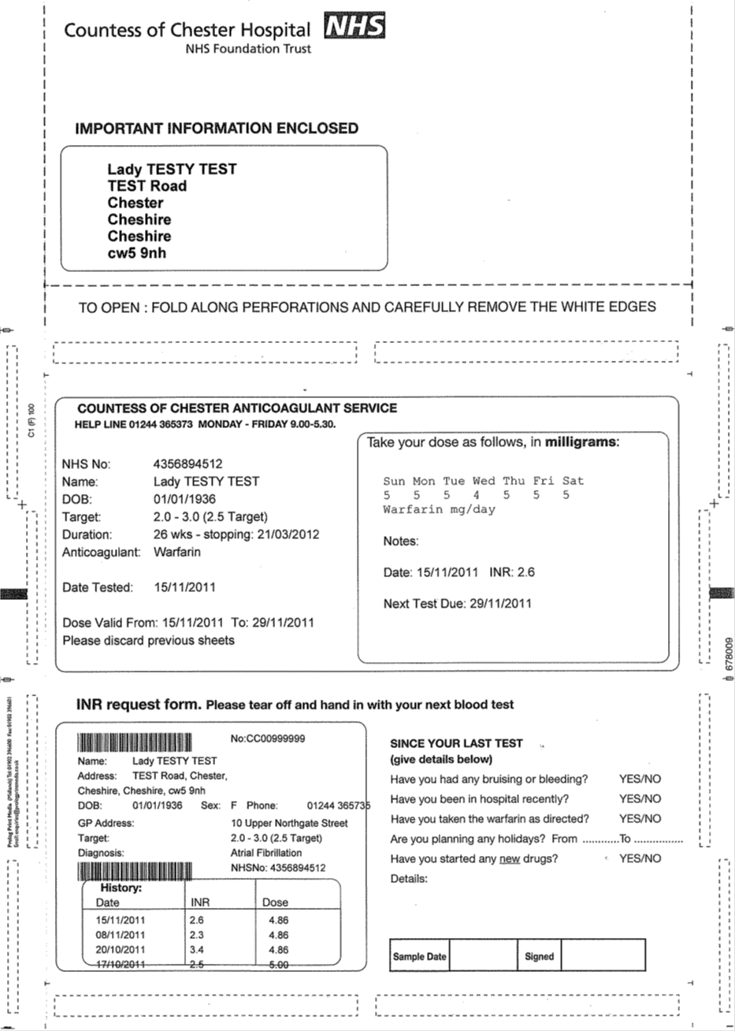

The Warfarin dosage sheet in use by the anti-coagulant monitoring service

Glucose tolerance test
The majority of glucose tolerance tests are now performed at GP surgeries. Please contact your family doctor for more details.

Information about post-mortem examinations
Click here for a link to further information contained on the website of the Human Tissue Authority.

PALS
The Patient Advice and Liaison Service (PALS) focuses on improving the service we provide to our patients.

When you need advice or have concerns about any aspect of your care in our hospital then please contact PALS.

The service is confidential.

We will:
• Provide advice and support for patients, their families, and carers
• Provide information on NHS services
• Listen to your concerns, suggestions or queries
• Help resolve problems quickly on your behalf

Freephone: 0800 195 1241 and select option 2 or phone 01244 366066
Email: cochpals@nhs.net or
Address: PALS Manager, PALS, Countess of Chester Hospital Foundation Trust, Liverpool Road, Chester CH2 1UL

confidentiality

The Pathology Dept. at the Countess of Chester Hospital NHS Foundation Trust is responsible for the management of all patient information obtained or created during the performance of laboratory activities, including privacy and confidentiality.
When the laboratory is required by law or authorised by contractual arrangements to release confidential information, the patient concerned shall be notified in advance of the information release (unless prohibited by law).

