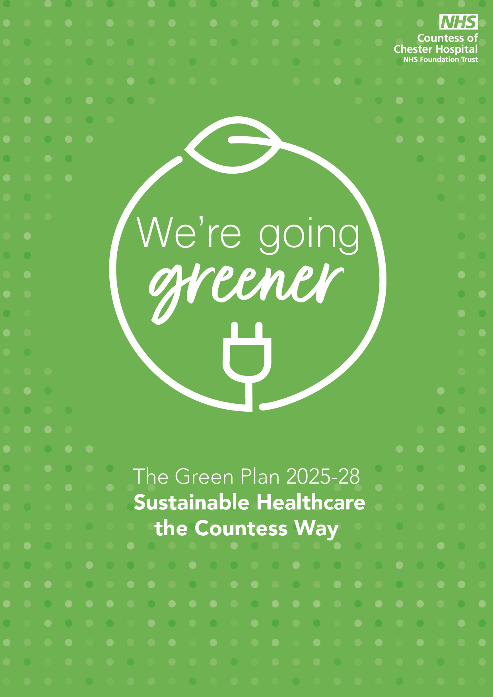

Foreword
Introduction
Building on our Progress
Refreshing our Green Plan
Areas of Focus
Green Plan Governance
Supporting Metrics - Our Target Condition


Foreword
In 2020, the NHS became the world’s first health system to commit to reaching net zero emissions. The Delivering a Net Zero National Health Service report set out the scale of ambition. The Health and Care Act 2022 reinforced this commitment, placing new duties on integrated care boards (ICBs), NHS trusts and foundation trusts (referred to collectively as Trusts) to consider statutory emissions and environmental targets in their decisions.
“Sustainability is about meeting our needs today without compromising the ability of others to meet their needs tomorrow”

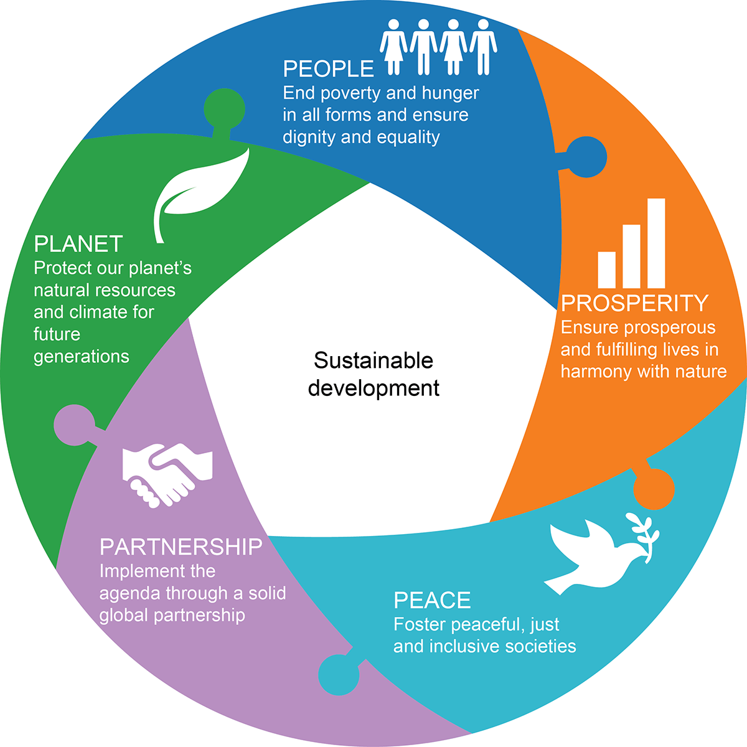
On 25 September 2015, the 193 Members of The United Nations General Assembly formally adopted the 2030 Agenda for Sustainable Development, along with a set of bold new Global Goals, which the then Secretary-General Ban Ki-moon, hailed
Sustainability is about using our resources sensibly and striking the right balance between ‘Environmental’, ‘Social’ and ‘Economic’ considerations.
The previous three years have given us good reason to re-evaluate much as we consider our position and tenure as human beings on our planet, and how we can adjust and repair what has been broken to make better our planet in order that it can continue to breathe life and sustain us as a race.
The majority of the people within the UK understand what sustainability is, but opinions can vary on its definition. This definition below talks about ‘needs’, not about “the environment”, “being green” or “saving the planet”:
Sustainable development is a dynamic process, which enables people to realise their potential and improve their quality of life in ways that simultaneously protect and enhance the earth's life support systems.
We cannot just add sustainable development to our current list of things to do but must learn to integrate the concepts of sustainability into everything that we do.
Cheshire West as a borough pumps out four million tonnes of carbon a year – making it the fourth largest carbon footprint of any UK borough – and much of that comes from heavy industry, particularly near Ellesmere Port. The current target from Cheshire West & Chester (CWAC) is to reduce carbon emissions by 80% (compared to 1990 levels) by 2050. The location of our Trust within this borough and our charge in reducing emissions has made that more difficult, yet that more urgent if we are to consider ourselves a truly sustainable organisation.
Sustainability for us in the NHS is much broader than this; amongst other things it is about how we deliver care, our part in creating a healthier, happier population and how we ensure we can afford to continue delivering care in the future. This will, of course, include ensuring our plans enable us to develop a sustainable workforce for the long term.
Sustainability and our move to NHS Net Zero is our new challenge, our Trust and its carbon emissions, our Trust and its ability to become more Sustainable.
Introduction
The first ever mandatory COCH Trust Green Plan (2022 – 2025) has reached the end of its valid period with this new Green Plan becoming our refreshed, developed, and robust plan to improve health outcomes, reduce costs, and minimise waste – continuing the NHS' journey to achieving net zero.
We at COCH have already charged key individuals with strategic leadership positions to tackle head on our impact to the global emergency, not just to our planet, but to our health, wealth and wellbeing of all in our region.
Despite the many challenges and pressures, we face within our Trust and wider, the NHS, these challenges also present new opportunities to deliver outcomes that are best for our patients, financially beneficial, and better for our planet. The Trusts new Green Plan will keep the following 3 principles in mind:
- Prioritising interventions that support world-leading patient care and population health, reduce inequalities, and tackle climate change and broader sustainability issues.
- Supporting organisations to plan and make considered investments while increasing efficiencies and delivering value for taxpayers.
- Ensuring every NHS organisation supports the NHS-wide ambition to reach net zero carbon emissions, reflecting on the learning from delivery to date
Lord Darzi highlighted the urgency of this agenda during November 2024,
‘The World Health Organisation has described the climate crisis as the “single biggest threat facing humanity.” Given the global health imperatives, the NHS must stick to its net zero ambitions. There is no trade-off between climate responsibilities and reducing waiting lists. Indeed, often health and climate are mutually reinforcing goals: cleaner air is good for the environment and good for respiratory health.’
Our plan is ambitious in what it sets out to achieve, it is deliberate in its ambition because the Net Zero carbon reduction aspect is a huge challenge and only those with a matched level of ambition can hope to achieve this target.

Whilst our efforts outlined within this plan will see much focus on carbon reduction, the Planet element of the 3 x P’s, we do not lose sight of the other two key elements within Sustainability, our People and Profits. If we in the future do not have ‘People’, trained, competent, wanting to be here to deliver all aspects of healthcare, we are not sustainable. If we can’t fund and finance our healthcare operation consistently and within budget, equally, it is not sustainable. This then, is our combined challenge, this is our refreshed ‘Green Plan’.
Sources of carbon emissions by proportion of the NHS Carbon Footprint Plus

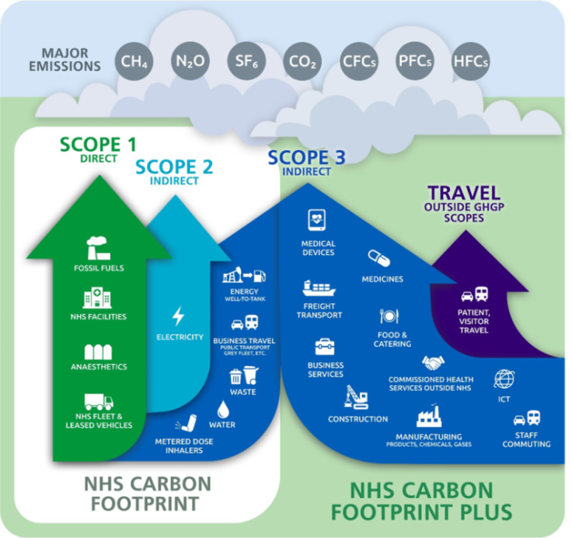
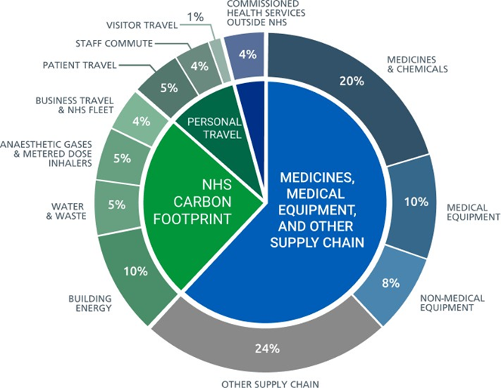

Building on our Progress
Whilst we have faced unprecedented demand from patients during the whole of the 24/25 period, along with sustained financial pressure to reduce costs, we have made progress in our Sustainability journey during the period of the 2022-2025 Green Plan.
During 2024/25, there has been progress in Sustainability projects across the Trust that has and will have a substantial impact on our patients, staff, and visitors:

- The formal publishing of the Trust Travel & Transport Strategy which became a key document in securing the approvals for our new Women & Children’s building project. As part of the same strategy, we successfully launched our own COCH Active & Alternative Travel initiative during September 2022, together with the opening of secure and sheltered cycle storage and staff changing rooms to support active travel. The event was extremely well attended and formally opened by Chris Boardman CBE. Chris Boardman is a former Olympic and World Champion and cycling and walking advocate and was appointed as National Active Travel Commissioner in June 2022 by the Transport Secretary. It was a very successful event, and Chris was very generous with his time and expertise in cycling and Active Travel for all attending participants
- The creation and opening of our very first ‘Going Greener Retail unit providing healthy food products and increase options for staff, patients, and visitors to access a variety of food options that support sustainability and health. This is aligned to the NHSE Prevention Pledge
- The approach of ‘sustainability by design’ focusing on ‘reduced energy consumption’ in the Women & Children’s building has continued fully in the build process for this exciting new Healthcare facility. The installation of air source heat pumps and solar PV to the roof elevations will achieve BREEAM excellence in design and build as part of the original local authority planning approvals
- Secured e-vehicles for the Trust Hospital @ Home as part of the Integrated Discharge Team who now only use the fully electrically powered e-vehicles
- Secured reduced fares for bus journeys to and from Park and Ride at Chester Zoo to reduce the impact of car parking on site for Trust Staff
- Complete removal of desflurane as an anesthetic gas within the theatre environment
- The final push toward the completion of the Women & Children’s building that will open during summer of 2025. Whilst not yet confirmed, it is widely expected that this brand-new healthcare facility will be accredited with achieving the NHS Net Zero Building Standard, the first to do so in the National Health Service
- The recruitment and appointment of Trust Sustainability Ambassadors continues with pace and enthusiasm from Trust members who have actively demonstrated the same enthusiasm and commitment to join up
- The Trust has maintained its positive collaboration with other Trusts to identify initiatives that benefit COCH and other Trusts within our ICS
The Sustainability Lead also represents the Trust at:
- Cheshire & Merseyside Sustainability Board that meets monthly. This Board is chaired by the C&M Regional Director for Sustainability
- Cheshire West Place Sustainability Committee
- Cheshire West and Chester Council Travel and transport Collaborative (membership consists of CWaC, COCH, Chester University and Chester Zoo)
- Ad hoc NHSE events directly connected to Sustainability
- Submitting progress data to Greener NHS (OKTA) quarterly submissions on four separate ‘Green’ themes
The Trust can be proud of its progress, considering the national challenge around available funding and regional funding pressures in maintaining and prioritising health services.
This new refreshed Green Plan sets out a vision and strategy for the Trust: Our target is to reduce our carbon emissions and make the principles of sustainability a natural part of our workforce and health care activities in the delivery of patient-centred care.
Our combined objective as part of the original NHS/E mandate for Carbon Net Zero is to reduce carbon emissions as follows:
- By 2040 for the NHS Carbon Footprint, with an ambition for an 80% reduction (compared with a 1990 baseline) by 2028 to 2032, everything directly in our control
- By 2045 for the NHS Carbon Footprint Plus, with an ambition for an 80% reduction (compared with a 1990 baseline) by 2036 to 2039, including supply chain, travel, construction etc

Refreshing our Green Plan
Our Green Plan sets out the key actions the Trust will take to deliver emissions reductions and support resilience to climate impacts over the next three years. This timeframe is considered a minimum and allows our Green Plan to strike an appropriate balance between immediate emissions reductions in some areas, alongside strategic development of capability in others.
Our Trust through its Green Plan will and continue to:
- Review progress to date and engage with key stakeholders about refreshing priorities; in particular, clinical and staff groups who underpin green plan delivery
- Take into account the national targets (and interim 80% emissions reduction goals) for the NHS carbon footprint and carbon footprint plus
- Set out SMART (specific, measurable, achievable, relevant and time-bound) actions and associated key performance indicators (KPIs) for each area of focus
- Ensure recommended governance arrangements and processes to measure and report on progress are in place
- Comply with any applicable legal duties, including the duty to reduce inequalities, the Public Sector Equality Duty and the duty to have regard to all likely wider effect of decisions
In addition, as a Trust, we will consider:
- The role of the local system and provider collaboration in supporting delivery, such as through the spread and standardisation of best practice
- Opportunities for collaboration with wider system partners to reduce emissions
- Engagement with research and innovation activities to support the transition to a net zero NHS
The NHS/E Green Plan refresh guidance document sets out the actions required from Trusts as well as the areas of focus for our refreshed Green Plan.
The guidance documents set out the national objectives against each specific focus area. Focus area priority actions and objectives lead each area heading in this document followed by how our Trust will work toward the achievement of such priority actions and objectives or has previously met the action/objective.
Areas of Focus
Workforce & Leadership
Key actions for Trusts
- Appoint a designated board-level net zero lead, generally an existing executive director, to oversee green plan delivery with clearly identified operational support
- Assess workforce capacity and skill requirements for delivering the green plan, considering good practice examples such as hybrid roles, apprenticeships, fellowships and NHS estates sustainability career pathways
- Promote, and consider setting uptake targets for, core training offers set out on the Greener NHS Training Hub
- Promote specialist training for staff groups who underpin the delivery of green plans, such as board members, procurement, finance, estates and facilities staff and clinicians
The Trust has a named designated Board level Net Zero Lead that will continue to oversee the Green Plan Delivery.
A named Trust Sustainability Lead is responsible for the writing of the Green Plan, periodic subsequent refresh and the delivery of the Green Plan, as well as monitoring and recording progress.
There is clear strong support for a greener future, with evidence that shows, nationally, 9 in 10 staff support the NHS Net Zero ambition and 6 in 10 staff say they are more likely to stay in an organisation that is taking decisive climate action (YouGov 2023).
The support for a greener future is just as strong at COCH, made even clearer during the very recent Cost Improvement Programme (CIP) Idea – Feedback initiative. An extremely high number of ideas and initiatives, whilst linked to cost saving, are strongly linked and beneficial to our Green Agenda.
Our new approach needs to assess workforce capability, and the skill requirements required to harness this energy and commitment to a Net Zero environment.
The promotion of specialist training for staff group who underpin the delivery of specific green plan initiatives is being investigated through The Sustainable Healthcare Academy.
The Sustainable Healthcare Academy is a new green skills initiative built specifically for those working in health and care. It is delivered by Ofsted Outstanding LDN Apprenticeships and has been built in partnership with the Centre for Sustainable Healthcare.
The new learning programme is underpinned by the Level 4 Corporate Responsibility & Sustainability Practitioner Standard – representing a levy-funded route to professionalisation for those who have an interest and passion for sustainability.
The development of the Academy has been supported by a steering group of 30+ advisers from across a range of NHS organisations, including Greener NHS. The strategic objectives of the Academy are:
- To embed skills that support the successful delivery and evolution of Green Plans
- To build a network of net zero advocates and critical thinkers that drive cultural and operational change
- To develop and embed self-sustaining sustainability initiatives
- To professionalise sustainability skills within the NHS workforce
- To deliver triple-bottom-line sustainability projects across a range of functions and departments (both clinical and non-clinical)
This new programme is open to all roles operating within healthcare and represents an excellent platform to embed the principles of a greener future and the ambition for NHS Net Zero in their role and task.
Net Zero Clinical Transformation
The NHS is committed to moving to out-of-hospital and digitally enabled care where clinically appropriate, improving prevention of ill health and reducing health inequalities. These changes also underpin our commitment to net zero. Net zero clinical transformation should ensure high-quality, preventative, low-carbon care is provided to patients at every stage.
Key actions for our Trust:
- Identify a clinical lead with oversight of net zero clinical transformation, with formal links into board-level leadership and governance
- Focus on reducing emissions and improving quality of care for at least one clinical area (see suggested areas below), for example by:
  - establishing a clinical lead and multidisciplinary working group responsible for reducing emissions in the clinical area(s)
  - completing quality improvement project(s) in the clinical area(s) that focus on a measurable reduction in emissions, with co-benefits for outcomes and quality of care, efficiency and reducing healthcare inequalities
  - Sharing learning and outcomes, for example, through clinical networks, the ICB and NHS England
We shall identify a senior clinical lead with oversight of net zero clinical transformation, with formal links into board-level leadership and governance. The designated Board level Net Zero Exec Lead is finalising the named clinical lead in response to this specific objective.
The named Clinical Lead will further,
- Establish a multidisciplinary working group responsible for reducing emissions in the clinical area(s)
- Identify the most appropriate and complete a quality improvement project in the selected clinical area that will focus on a measurable reduction in emissions, with co-benefits for outcomes and quality of care, efficiency and reducing healthcare inequalities
- Share the learning and outcomes, through clinical networks, the ICB and NHS England
- Consider net zero principles in all service change, reconfiguration programmes and pathway redesign
The four clinical areas suggested due to their high carbon intensity or volume as part of the national objective are:
- Critical and Perioperative Care
- Urgent and Emergency care
- Diagnostic Tests and Procedures
- Medical Pathways, with a focus on acute or long-term conditions such as renal disease, diabetes or cardiovascular disease
The named Clinical Lead will advise of which high carbon intensity or volume area is selected, and specific metrics will be produced to monitor progress, carbon reduction and wider improvement in patient care.
We will become a health promoting hospital, working in new ways with community partnerships to individualise care and empower communities in creating greater social vale. We want to move away from over prescribed / hospital-based case and support communities in their own management in living healthier and longer lives.
We are supporting patients with chronic illnesses through education and management strategies can lead to improved quality of life and reduced hospital readmission rates. We partner with local organisations to address broader health issues that can strengthen community ties and health outcomes.
We are focusing on sustainability, reducing the environmental impact of the hospital, and implementing policies like smoke-free environments, healthy food options, and physical prehabilitation activity in the promotion and adoption of a holistic approach to health.
We will lead on educational events promoting preventative opportunities, increase our outreach for antenatal educations and frailty classes. We will collaborate with Cheshire Wirral Partnership Trust in areas such as health checks, vaccinations, and work with local industry. We will work with local schools providing education, health awareness and career opportunities as well as early diagnosis and audiology services.
Digital Transformation
Strong digital foundations are essential for transforming care by improving access, quality, productivity and reducing emissions. However, digital services can also increase emissions.
NHS England’s through the launch of its ‘What good looks like’ framework encourages NHS organisations to prioritise sustainability in the procurement, design and management of digital services to meet the objectives of the Greening Government: ICT and Digital Services Strategy.
Key actions for our Trust:
- Maximise the benefits of digital transformation to reduce emissions and improve patient care, for example, by reducing the use of paper and providing virtual pathways where clinically appropriate
- Supported by the ‘Digital Maturity Assessment, we shall consider opportunities to embed sustainability in digital services, such as:
  - using circular and low-carbon approaches to IT hardware management, which may include longer device lifetimes, leasing models, buying refurbished or remanufactured equipment and PC power down configuration
  - considering low carbon hosting, promoting good data hygiene (such as, deduplication and archiving) and engaging digital suppliers
The Trust has an Electronic Patient Record (EPR) which enables digital processes and workflows. There is an ongoing programme of work, to further develop the EPR and reduce the use of paper across the trust.
This work includes a focused reduction of printing and postage.
The EPR development work is overseen by the trusts Chief Clinical Information Officer who works alongside the Digital and Data team.

- The Trust is investing in its Virtual Desktop Infrastructure (VDI) platform, which will increase device usable lifetimes and reduce device energy consumption
- Last year a programme of work was completed to reduce the energy utilisation of monitors when not in use. Phase 2 of this programme will take place this year to reduce energy utilisation of desktop PC’s and laptops when not in use
- In 24/25 the Trust invested in a new Storage Area Network, which allows for a high level of duplication and reduced power utilisation
- Digital and Data teams are continuing to work with suppliers, to find digital alternative solutions to current manual or physical processes

Medicines –
Medicines account for around 25% of all NHS emissions. A few medicines account for a large portion of these emissions, for example, anaesthetic gases (2% of NHS emissions) and inhalers (3%). As a Trust, we shall continue to build on progress in reducing these “point of use” emissions, while improving patient care and reducing waste.
Actions to reduce emissions from the medicines supply chain are set out under Supply chain and procurement.
Key actions for our Trust:
- Reduce nitrous oxide waste from medical gas pipeline systems (MGPS) by progressing the actions outlined in the updated nitrous oxide waste mitigation toolkit
- Cease use of the volatile anaesthetic agent desflurane in line with national guidance, allowing exceptional use only as published by the Neuro Anaesthesia and Critical Care Society
In addition, trusts may wish to:
- Support high-quality, lower-carbon respiratory care in secondary care, including supporting patients to choose the most appropriate inhaler(s) in alignment with clinical guidelines, performing inhaler technique checks with patients and promoting the appropriate disposal of inhalers
As a Trust we aim to reduce the environmental impact of the medicines we use by, the type of products we procure, minimising medicines waste, reducing overprescribing and supply, and using best practice to dispose of any waste.
We have focussed on some key areas to meet the National Objective:
Anaesthetic gases:
Anaesthetic gases contribute about 2% of the NHS’s carbon footprint. Nitrous oxide makes up approximately 75% of this. The Trust is currently working towards minimising our nitrous oxide waste across the site and has applied for NHS England funding to support this work further.
Desflurane, another anaesthetic gas, which has a much higher environmental impact with a global warming potential of 2,500 times greater than carbon dioxide. Our Trust ceased the use of the volatile anaesthetic agent Desflurane in line with national guidance during 2021.
Reducing these emissions helps tackle climate change, lowers air pollution and supports NHS net zero goals.
Inhalers:
A review of inhaler prescribing is currently being undertaken by the pharmacy team to look at our adherence with the local formulary. One of the aims of this work is to improve our use of inhalers with a lower carbon footprint e.g. dry powder inhalers, where these are clinically appropriate for our patients.
Deprescribing:
Our pharmacists support our prescribers to reduce doses or discontinue medicines that may be causing patient harm or are no longer of benefit or required by the patient. As well as improving patient outcomes by reducing risks such as falls or cognitive impairment, this also prevents the environmental and economic costs of overprescribing. We are currently auditing the impact of this in our acute frailty unit.
Medicines waste:
Reducing medicines waste has both a positive environmental and financial impact. We have robust systems to minimise stocks expiring and we return and reuse items where possible. We encourage patients to bring their medicines to hospital with them via the green bag scheme and use these medications during their inpatient stay, supplying only what is needed on discharge.
Homecare:
The pharmacy homecare team facilitate the delivery of hospital only medicines directly to over 2400 patients within their own homes, supporting the green agenda by reducing the number of patients that travel to site to collect their prescriptions and decreasing the demand on the hospital infrastructure. Homecare often reduces overprescribing and therefore lessens waste.
Travel and Transport
The NHS fleet is the second largest in the country, consisting of over 20,000 vehicles. It directly contributes to harmful air pollution. The NHS Net zero travel and transport strategy outlines a roadmap to decarbonise NHS travel and transport, while also providing cost-saving and health benefits.
Key actions for Systems and Trusts:
- Develop a sustainable travel plan by December 2026, to be incorporated into the green plan (for example, as an annex), focusing on active travel, public transport and zero-emission vehicles, supported by a clear understanding of staff commuting (NHS England guidance will be available in 2025)
- Offer only zero-emission vehicles through vehicle salary sacrifice schemes from December 2026 onwards (for new lease agreements)
- Make arrangements to purchase, or enter into new lease arrangements for, zero-emission vehicles only from December 2027 onwards (excluding ambulances)
Travel and transport remain a key objective at our Trust, in providing much improved options for travel as well as plans to improve the car parking infrastructure at both of our sites. We have made some progress in this area against incredibly challenging external factors, local public transport service cuts, and cancellation of ineffective bus routes, all of which do not support an ‘alternative’ mode of travel.

- Our original Travel & Transport Strategy is due for refresh and is timely in line with the national NHS objective (develop a sustainable travel plan by December 2026, to be incorporated into the green plan (for example, as an annex), focusing on active travel, public transport and zero-emission vehicles, supported by a clear understanding of staff commuting) will take into account the results of the Trust staff Travel & Transport survey as well as meeting the NHS national objectives. This specific document has proved essential in the future planning of the Health Park in applying for any planning/building approvals from local authority. In terms of positioning the Trust for any such future planning applications, it is critical that this document can demonstrate progress and ambition in how it is managing travel and car parking demand at our sites.
- Work is already underway both nationally and at a regional level to secure the objective (offer only zero-emission vehicles through vehicle salary sacrifice schemes from December 2026 onwards (for new lease agreements). NHS/E Transport as part of National Operations have confirmed that all vehicles offered through the NHS salary sacrifice scheme will be electric by the end of 2026 and all new vehicles owned or leased by the NHS will be zero emission by the end of 2027 (excluding ambulances).
- We shall work with our Executive Team and Finance colleagues to secure the offer of only zero-emission vehicles through vehicle salary sacrifice schemes from December 2026 onwards (for new lease agreements). The previous twelve months show that our staff (116 staff members from a total of 124 staff members) have elected to acquire e-vehicles through the Trust vehicle lease scheme. The transition to e-vehicles rather than fossil fuel vehicles has very much begun and making huge progress within our own staff base.
- During April 2025, we collectively secured a full fleet replacement (7 x vehicles) for our Trust which consists of 3 x e-vehicles and 4 x hybrid vehicles. The new vehicles are due for delivery in May 2025
The Transport Services fleet collect samples from across the region from GP practices and transport to either our own Trust blood sciences unit or our partner laboratory in Bromborough.

The annual milage for this combined fleet is approx. 177,000 miles. The mix of fully electric and hybrid vehicles will make a substantial contribution to cost savings in the huge reduction in diesel costs associated with operating this size of fleet as well as a carbon emissions reduction.
Where previously our vehicles would return an average of 40 miles to the gallon, our new Hybrid vehicles will achieve 65+ miles to the gallon.

The fully e-vehicles are replacing 3 x vehicles who returned an annual mileage of 60,000 per year. The new fully electric variants will now no longer use revenue budget to purchase fossil fuel, good for cost saving and excellent toward Net Zero.

This achievement, whilst important to our own Net Zero ambition, is 1.5 years ahead of the national objective (make arrangements to purchase, or enter into new lease arrangements for, zero-emission vehicles only from December 2027 onwards).

A further NHS/E objective is - form partnerships with local authorities and local transport authorities to maximise funding and infrastructure opportunities on behalf of the ICS member organisations.
Our Trust has operated within a collaborative group for the previous two years, membership consisting of the four biggest employers in the city (COCH, Local authority, Chester University, Chester Zoo) with membership extended to ‘McArthurGlen’ who manage and operate the Cheshire Oaks retail outlet centre at Ellesmere Port. The focus of this group is Travel Demand Management and working together with local bus operators including CWAC to improve the travel options to users and reduce congestion from the main Liverpool Road which connects the attending group of organisations.
The third Trust staff Travel & Transport Survey (mandated as part of NHS Net Zero) went live at the beginning of April 2025 and will remain open for comments etc for a calendar month. The feedback from Trust staff helps understand the steps we shall take to resolve travel & transport and car parking concerns at out 3 Trust sites.
Estates and Facilities
There are significant opportunities across the NHS estate to reduce emissions and lower costs, while improving energy resilience and patient care.
Organisations should focus on:
- Improving energy efficiency by installing measures such as LED lighting, insulation and double-glazed windows
- Replacing fossil fuel heating systems with lower carbon alternatives, such as heat pumps or connecting to a heat network system
- Increasing use of renewable energy by investing in on- or near-site renewable energy generation to meet NHS energy demand
Key actions for Trusts:
- Develop a heat decarbonisation plan (HDP), which includes:
  - Identifying and prioritising the phasing out of all existing fossil-fuel primary heating systems by 2032 and seeking to remove all oil primary heating systems by 2028
  - Considering Local Area Energy Plans and opportunities from heat networks and other low-carbon solutions
  - Identifying any installations in scope of the UK Emissions Trading Scheme and outline plans to reduce emissions in line with allocated targets
- Develop business cases to deliver the measures outlined in the HDP, as well as accompanying energy efficiency and renewable energy interventions, with a view to submitting a funding application through the PSDS if projects cannot be financed through internal budgets
- Ensure all applicable new building and major refurbishment projects are compliant with the NHS Net Zero Building Standard
Our Trust has made huge strides in achieving these key objectives around energy. The trust formally commissioned a nationally reputable organisation to undertake a full assessment of the heating and energy infrastructure across the site and produce a full documented HDP. This document outlined the steps the Trust shall take in achieving full heat decarbonisation. The full plan requires substantial investment over the next 8 years to achieve its heat decarbonisation objective, which against other conflicting financial priorities, makes the objective of a full heat decarbonisation achievement even more challenging.
Replacement LED lighting has previously been achieved in full throughout the Trust and has made a significant contribution in energy usage.
Our Trust has three hospitals within its portfolio and LED replacement work is required further at Ellesmere Port Hospital and Tarporley War Memorial Hospital.
All new build projects and refurbishment projects within the portfolio of COCH will include provision for insulation and double-glazed windows as part of the scheme, further impacting our capacity to conserve heat and reduce energy costs.
The new Women & Children’s building in its initial design phase was set to achieve a ‘BREAM Excellent rating. (BREEAM (Building Research Establishment Environmental Assessment Method) is a widely recognized sustainability assessment method used for buildings, particularly in the UK and internationally. It assesses the environmental, social, and economic performance of buildings throughout their lifecycle, from design and construction to operation and refurbishment.
The ongoing success of this project and not without its challenges, is now set to become the first building within the NHS to achieve full compliance with the new NHS Net Zero Building Standard.
Achieving the position of first in NHS UK is absolute testament to this project and how it has been managed and built throughout, up to its handover to the Trust in summer 2025. The NHS has been and is still, facing some of its biggest challenges in its history, this achievement of ‘first in NHS UK’ is significant for our Trust considering such wider challenges.
Continuing with the theme of ‘first’, the Trust is seriously exploring the possibility of extracting geothermal energy from deep within the earth.
Geothermal extraction is the process of harnessing heat from the Earth's interior for various uses, including heating, cooling, and electricity generation. It involves extracting thermal energy from hot rocks or underground fluids and converting it into usable forms of energy. This process can be achieved through different methods depending on the geothermal resource and its location
Deep geothermal systems involve drilling deep wells to reach hot rocks or underground fluids at depths of 500 meters to 1.5 kilometres down within the earth.
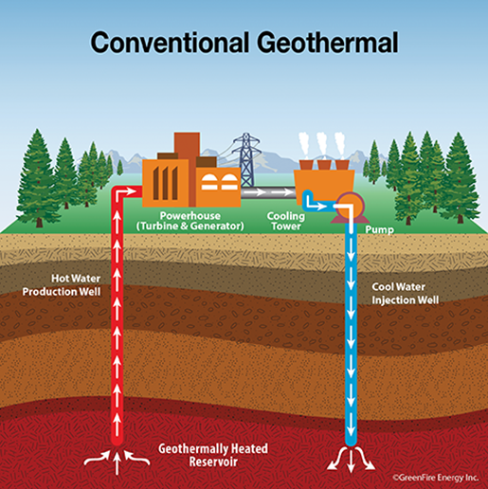
The extracted heat can be used for direct heating applications like district heating networks for domestic or commercial space heating, or in some cases, for power generation. The approach our Trust is taking makes a huge impact in the National objectives placed up on us (Heat networks, low carbon energy alternative and renewable energy use).
The project is planned to run over the next three years and formally commenced in early 2025.
This project if successful, cannot be understated in its capacity to substantially reduce energy costs, help us become more energy efficient at the Trust and achieve NET Zero in one single project.
If successful and on completion, our Trust will be the first Trust within NHS/E to have achieved this type of energy extraction and use.
Sustainability is also about sustaining our finances. Maintaining a close eye on how we use the public purse has supported and guided us in how we maintain Trust furniture. In collaboration with our procurement colleagues, we have sourced the services of an external organisation that will repair and re-upholster damaged furniture rather than a direct purchased replacement.
A standard 3-seater set of waiting area chairs cost approx. £680 to renew. We can repair re-upholster the damaged seats and back rests for less than £75 inc vat. The other obvious positive with this approach is that of less waste and less cost in the disposal of such waste.
The same rationale can and will be applied to examination couches and benches as part of maintaining our assets and extending the life of such for our patients and visitors. Whilst this approach can be classified as value added, there is an important reputational aspect to this project. We must consider how our patients and visitors feel and probably perceive how their own health care service will be if we are not seen to be maintaining our environment and ensuring all assets are fit for purpose.
Supply Chain & Procurement
The NHS net zero supplier roadmap outlines steps suppliers must follow to align with the NHS net zero ambition between now and 2030. Roadmap implementation is a shared responsibility across trusts, systems, regional procurement hubs and nationally. Organisations should also seek to embed circular solutions, such as using reusable, remanufactured or recycled solutions when clinically appropriate, which are often cost saving.
Key actions for systems and trusts:
- Embed NHS net zero supplier roadmap requirements into all relevant procurements and ensure they are monitored via KPIs
- Encourage suppliers to go beyond minimum requirements and engage with the Evergreen Sustainable Supplier Assessment to support a single conversation between the NHS and its suppliers on sustainability priorities
In addition, trusts should:
- Reduce reliance on single-use products, considering how to safely build this work into clinical improvement projects
The national roadmap to net zero for suppliers was detailed by NHE/I in September 2021 with the key objectives set out below.
- From April 2023, we will require suppliers to publish carbon reduction plans from 2023 for contracts over £5m and for contracts of any value from 2024
- From April 2027, suppliers will have to account for their direct and indirect emissions in published carbon reduction plans
- From April 2028, new requirements will be introduced overseeing the provision of carbon foot printing for individual products supplied to the NHS
From 2030, suppliers will only be able to qualify for NHS contracts if they can demonstrate their progress through published progress reports and continued carbon emissions reporting through the supplier framework. A Supplier Framework for benchmarking and reporting progress against these requirements was made available in 2022. The Trust has developed tender documentation to reflect the ability of suppliers to meet the Net Zero carbon requirements
The Countess of Chester Hospital NHS Foundation Trust Procurement have introduced the below to meet the above objectives so far:
- Procurement have now embedded the requests for Carbon Reduction Plans (CRP) / Net Zero Commitments (NZC) into all Tenders
- Each Supplier used by the Trust have provided their CRP / NZC Plans, and these are stored electronically within the Procurement Department - no matter the spend
- The revised new supplier forms incorporate the requirement for these plans before suppliers are set up on the Trust Purchase Order System
- The Trust encourages suppliers to go beyond minimum requirements and engage with the Evergreen Sustainable Supplier Assessment
- Social Value of 10% is embedded into all Tenders when evaluating
- Working with suppliers to reduce their carbon footprint – for Example NHS Supply Chain who are part of the NHS Family, are committed to meeting the NHS net zero carbon targets: Aiming for Net Zero for the NHS Footprint by 2040
- Reduce, Reuse and Recycle to reduce waste going to landfill – for Example recycling / reusing furniture that is surplus
- Ensuring Procurement staff have undertaken Carbon Literacy Training
Additional work that has been undertaken between Procurement and stakeholders include the reduction of single-use products as per legislation. In addition, changing clinical products which have reduced plastic i.e. Suction Liners and Sharps Bins
Food & Nutrition
Organisations should continue implementing the National standards for healthcare food and drink, requiring NHS organisations to deliver high-quality, healthy and sustainable food and minimise waste.

Key action for trusts:
- Measure food waste in line with the Estates Returns Information Collection (ERIC) and set reduction targets
- Consider opportunities to make menus healthier and lower carbon by supporting the provision of seasonal menus high in fruits and vegetables and low in heavily processed foods
We remain proud of our own in-house Catering Service who produce approx. 600+ healthy, nutritional meals every day, three times per day for our patients and staff. All our meals are prepared from fresh produce and ingredients and changed daily to provide variety of options.
Our in-patient meals are produced to the exact requirements of our individual in-patients with additional expertise and advice from our Trust dieticians and nutritionists, resulting in a very bespoke and personal meal for each in-patient.
Our ‘belted & personal’ meals service results in minimal food waste leaving our Trust, further providing excellent fiscal use of our allocated budget. Any food waste leaving site is recorded and weighed as a requirement of NHS/England and dispatched to a local processing site and made into gas energy for regional domestic and commercial use.
The Trust, through Catering Services has been approached to take part in “Sustainable & Inclusive Nutrition for All: Testing Low-Carbon Menus in Hospitals”. The project is fully funded by the National Institute of Health and Care Research (NIHR).
The final approval papers are being submitted by NIHR, and we will know soon when the project is to commence. The project aims to trial and evaluate a behaviour change intervention to reduce carbon emissions within the NHS and increase consumption of healthy and sustainable hospital food by patients.
Adaptation
Climate change threatens the ability of the NHS to deliver its essential services in both the near and longer term. Resilience and adaptation should be built into business continuity and longer-term planning to avoid climate-related service disruptions. Partnership working between sustainability leads, public health, emergency response teams and estates leads at trust and system level is crucial.

Key actions for systems and trusts:
- All providers and commissioners of NHS-funded services must comply with the adaptation provisions within the NHS Core Standards for emergency preparedness, resilience and response (EPRR) and the NHS Standard Contract to support business continuity during adverse weather events
- Set out actions to prepare for severe weather events and improve climate resilience of local sites and services, including digital services (see Annex B: selected resources for a supporting Climate Change Risk Assessment Tool)
In addition, trusts should:
- Factor in the effects of climate change when making infrastructure decisions and designing new facilities, including enhancements like improved green spaces, drainage systems and passive cooling solutions
- Ensure adequate cascading of weather health alerts and relevant messaging across the organisation, in line with the government’s Adverse Weather and Health Plan
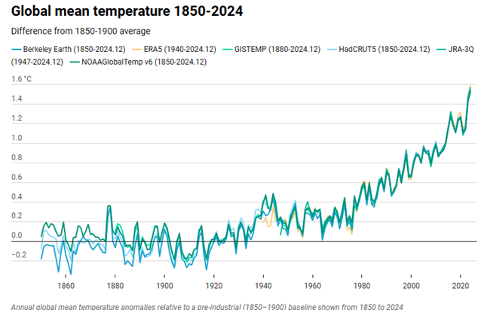
Our climate is rapidly changing. With 6 of the last 10 years (2014-2023) ranking among the warmest on record since 1884, the impacts are already proving costly to both society and the NHS, with future costs expected to rise. While estimating the full extent is challenging, heat-related mortality in England alone costs £6.8 billion annually, likely to increase to £14.7 billion per year by the 2050s. These figures underscore the urgent need for action.
Despite rapid decarbonisation, global temperatures will continue to rise, and without adaptation, health impacts from heat, cold and flooding will worsen due to climate and sociodemographic changes. Emissions reduction and climate adaptation are mutually reinforcing, essential aims to minimise the adverse effects on population health and health services. The health sector’s resolve to adaptation is ever more essential given the vulnerability of the population we serve.
State of the Climate Report 2024
The World Meteorological Organization (WMO) have published the latest State of the Global Climate Report, looking back at 2024. This report confirmed that 2024 was the warmest on record globally, and likely the first calendar year to be more than 1.5°C above the pre-industrial era, with a global mean near-surface temperature of 1.55 ± 0.13.
Met Office chief scientist, Professor Stephen Belcher said:
“The latest planetary health check tells us that earth is profoundly ill. Many of the vital signs are sounding alarms. Without serious efforts to heed the warnings, extreme weather events - such as drought, heatwaves and flooding - will continue to worsen.”
The greatest climate risks to the health and care system in Cheshire & Mersey region are a.) risks to wellbeing from high temperatures; b.) river and surface flooding; c.) coastal flooding; d.) risks to building fabric.
Climate change has serious consequences for:
- Delivery of healthcare service: ranging from risks to hospital estate, supply chains and transport
- Public health: new pressures on the health system as a result of heatwaves, pests and diseases, heat exposure, and extreme weather events

These issues particularly impact more vulnerable people and places. Understanding, anticipating, and adapting to these new challenges is essential to developing a more climate-resilient NHS.
The Trust Sustainability Lead has completed the training programme ‘Becoming Climate Resilient’ funded by NHS England that allows attending candidates to explore the key concepts of climate adaptation, climate risk, and identify opportunities to build resilience towards a fairer, flourishing future.
As a Trust, the Climate Change Risk Assessment Tool will be used to assess our current position.
The positional status will then determine our approach as part of a formal Trust Climate Adaptation Plan which will identify our key priorities in how we adapt to such changes.
Adaptation does not just consider our current buildings and infrastructure but shall assess:
- Our population and the potential impact to health from climate change
- Our staff and where they are populated/reside and their route of travel to the workplace
- And the utility and service companies that provide energy, water and daily supplies to our Trust
Green Plan Governance
Delivery of green plans should be overseen by a designated board-level net zero lead, generally an existing executive director, with clearly identified operational support.
The plan will also require senior leadership and oversight of delivery from a range of functions, which may include:
- Chief medical, chief nursing, chief allied health professional officers and chief pharmacists
- Directors of estates and facilities
- Directors of procurement
- Chief information officers
- Directors of finance
Organisations should put in place governance arrangements to co-ordinate delivery, such as a regular green plan delivery board chaired by the organisation’s board-level net zero lead and attended by relevant directors.
Each organisation should review and update its plans annually to consider progress made and any new priorities, guidance, technology and other enablers.
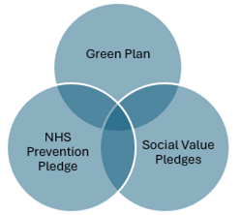
The delivery of the Trust Green Plan is overseen by a designated board-level net zero lead, as well as with clearly identified operational support.
To oversee the full range of workstreams within the Trust we have now established a strategic delivery oversight group (Anchor Institution Group) bringing together the following interdependent workstreams provides cohesion and coordination of our combined efforts to become an Anchor Institution.
As a Trust, we have formally signed the Cheshire and Merseyside Anchor Institute Framework. The Framework was co-produced throughout 2020 and 2021, working with colleagues across the Integrated Care Partnership, those from other systems and members of the public. It was officially launched by the Integrated Care Board Chair, Raj Jain, and Chief Executive, Graham Urwin, on 12th July 2022. It has defined Cheshire and Merseyside Integrated Care Partnership as an anchor system.
This Framework builds on work that has taken place across Cheshire and Merseyside, since becoming an NHS England Social Value Accelerator site in 2018. The purpose is to provide a framework that organisations who deliver services in Cheshire and Merseyside, can sign up to publicly demonstrate their commitment. The Framework aligns with existing work programmes, such as the Marmot Programme, and is intended to be a process to pull together all the great examples of delivering social value across Cheshire and Merseyside, in one place.
By signing the document, the Trust will be required to deliver on all the priorities and be able to demonstrate this at the Anchor Assembly, which is made up of senior system leaders and will take place within a 12-month period of the Trust becoming a signatory.
An oversight dashboard has been developed with clinical and operational leads identified for each workstream. In summary these workstreams and key lines of inquiry include.
Green Plan – Summary of indicators used
- Governance - Board updates and reporting
- Workforce - Staff awareness and training
- Clinical leadership - Considerations of carbon impact of care delivery through a clinical lens
- Digital transformation - Use of cloud solutions and repurposing of hardware
- Digital strategy - Commitment to meeting net zero ambitions as per National digital strategy
- Travel and Transport - Move to Electric Vehicles (EV) within Trust fleet, travel incentive schemes, transport partnership and active travel
- Estates and facilities
  - Move to 100% renewable Rego, certified electricity.
  - Energy meterage
  - LED lighting replacement
  - Use of building management systems to monitor and manage energy use
  - Local energy management solutions.
  - Off-site renewables
  - Proportion of decarbonization of heating across all sites.
  - Waste segregation
- Medicines Management
  - Audit of waste generated from piped nitrous oxide and decommissioning as required
  - Move toward the use of dry powder inhalers
  - Removal of harmful anesthetic gases (Desflurane)
  - Reduction in medicine management waste
  - Net zero impact on supply chain management
- Supply chain - Inclusion of a carbon reduction weighting in all procurement
- Food and nutrition
  - Meal ordering systems
  - Seasonal products
  - Monitoring of waste produced
  - Proportion of fruit and vegetables, pulses, and other low carbon ingredients
- Climate changes adaptations
NHS Prevention Pledge – Summary of indicators used
- Embedding prevention within our governance structures
- Quality improvement for prevention
- Using Marmot principles in service design
- Lifestyle approaches to CVD and stroke prevention and rehabilitation
- Establish key anchor practices
- Systematically adopting and embedding a ‘Making Every Contact Count approach
- Work with primary care, local authorities and VCSO’s to systematically refer to sources of non-clinical support through social prescribing
- Support workforce development, providing training and/or resources to frontline staff to offer brief advice and/or referral in supporting patients to eat well, be physically active, reduce harm from tobacco and alcohol and promote mental well-being
- Ensure a smoke-free environment, linked to support to stop smoking for patients and staff who need it
- Foster an organisational culture that promotes workplace resilience and creates opportunities for staff to eat well, be active, reduce harm from tobacco and alcohol and promote mental well-being
- Review food and drink provision across all our NHS buildings
- Increase public access to fresh drinking water on NHS sites
- Support the sub-regional physical activity strategy
- Sign up to the ‘Prevention Concordat for Better Mental Health for All
- Monitor the progress of the pledge against all commitments
Social Value Pledges – Summary of indicators used.
- Health and Wellbeing
- Education and Skills
- Employment and Volunteering
- Environmental (Cross over with Green Plan)
- Economic Social and Community
- Crime and Justice
- Housing
- Leadership

Conclusion
Countess of Chester Hospital NHS Foundation Trust is an example of an organisation that recognises the wider role that it can play in the communities that it serves.
The Trust will use its systems leadership role to deliver those pledges within our direct control and to facilitate those pledges which require new ways of working in partnership with other NHS Providers, Place, Local authorities, and the voluntary and charitable sector.
The development of our Strategic Delivery Oversight Group provides a comprehensive and cohesive response to key interdependent workstreams and provides vital evidence of action and progress for the new single CQC assessment framework, which now includes substantiality as a line of enquiry.
The Green Plan is further supported in oversight of delivery from a range of functions which are represented through the Anchor Institute Steering Group, as follows:
- Designated Non-Executive Director
- Leaders from Estates and Facilities Services
- Leaders from Procurement/Supply Chain
- Leaders from Communications/Information officers
- Leaders from Capital projects
- Leaders from Pharmacy/Medicines
- Leaders from Digital Transformation & Digital Strategy
- Leaders from Travel and Transport
- Leaders from Food & Nutrition
- Leaders from Social Value
- Leaders from NHS Prevention Pledge/Quality Improvement
- Leaders from Adaptation
Supporting metrics – Our Target Condition
The table below sets out our metrics for tracking progress against our Green Plan delivery. The list is not exhaustive and may be updated as new data streams become available.
Progress against each metric as well as the recording within the OKTA platform for Greener NHS dashboard and ERIC, will be cascaded and discussed at the Anchor Institute Steering Group.

Focus area | Metric | For use by | Data source
Workforce | Named board-level lead for green plan delivery | Trusts and systems | Greener NHS dashboard (from Q1 25/26)
Medicines | Emissions (tCO₂e) and volume (litres) of nitrous oxide by trust | Trusts and systems (aggregate of trust data) | Greener NHS dashboard
Medicines | Emissions (tCO₂e) and volume (litres) of nitrous oxide and oxygen (gas and air) by trust | Trusts and systems (aggregate of trust data) | Greener NHS dashboard
Medicines | Average inhaler emissions per 1,000 patients | Systems (aggregate of primary care data) | Greener NHS dashboard (from Q1 25/26)

Focus Area | Metric | For Use By | Data Source
Medicines | Mean emissions of Short-acting beta-2 agonists (SABAs) inhalers prescribed | Systems (aggregate of primary care data) | Greener NHS dashboard
Medicines | % of non-SABA inhalers that are MDIs | Systems (aggregate of primary care data) | Greener NHS dashboard
Travel and transport | % of owned and leased fleet that is ultra-low emission vehicle (ULEV) or zero-emission vehicle (ZEV) | Trusts and systems (aggregate of trust data) | Greener NHS dashboard
Travel and transport | Total fleet emissions | Trusts and systems (aggregate of trust data) | Greener NHS dashboard
Travel and transport | Does the organisation offer only ZEVs in its salary sacrifice scheme | Trusts and systems (aggregate of trust data) | Greener NHS dashboard

Focus Area | Metric | For Use By | Data Source
Travel and transport | Does the organisation operate sustainable travel-related schemes for staff (for example, salary sacrifice cycle-to-work) | Trusts and systems (aggregate of trust data) | Greener NHS dashboard
Estates and facilities | Emissions from fossil-fuel-led heating sources | Trusts and systems (aggregate of trust data) | Greener NHS dashboard
Estates and facilities | Number of oil-led heating systems | Trusts & systems (aggregate of trust data) | Estates Return Information Collection/Greener NHS dashboard (from Q4 24/25)
Estates and facilities | % of gross internal area covered by LED lighting | Trusts and systems (aggregate of trust data) | Estates Return Information Collection/Greener NHS dashboard (from Q4 24/25)
Estates and facilities | % of sites with a heat decarbonisation plan | Trusts and systems (aggregate of trust data) | Estates Return Information Collection/Greener NHS dashboard (from Q4 24/25)

Focus Area | Metric | For Use By | Data Source
Supply chain and procurement | Inclusion of Carbon Reduction Plan and Net Zero Commitment requirements in all relevant procurements | Trusts and systems | Greener NHS dashboard
Supply chain and procurement | Inclusion of requirements for a minimum 10% net zero and social value weighting in procurements, including defined KPIs | Trusts and systems | Greener NHS dashboard
Food and nutrition | Weight (tonnes) of food waste, with further break down by spoilage, production, unserved and plate waste | Trusts and systems (aggregate of trust data) | Estates Return Information Collection

Focus Area | Metric | For Use By | Data Source
Food and nutrition | Weight (tonnes) of food waste, with further break down by spoilage, production, unserved and plate waste | Trusts and systems (aggregate of trust data) | Estates Return Information Collection
Adaptation | Number of overheating occurrences triggering a risk assessment (in line with trust’s “heatwave” plan) | Trusts and systems (aggregate of trust data) | Estates Return Information Collection
Adaptation | Number of flood occurrences triggering a risk assessment | Trusts and systems (aggregate of trust data) | Estates Return Information Collection

